
Design Review and Stakeholder Presentation: Supporting Material
Session 6. Reference for Activities 1 to 3: read the sections each activity names.
Fictional organisation and synthetic data: the organisation, its people and its figures are invented for teaching.
Keep it confidential: no personal or customer data, credentials or confidential material, and no employer data in AI tools your employer has not approved.

1. What goes in your design pack
Your pack explains one feature well enough for someone else to review, build and test it. Use this list to check your pack in Activity 1.
Part | What it must show | Practised in
Requirements R1 to R3 | Three requirements for one feature, numbered, each testable | Session 3
Stories (core) | One user story per requirement (As a ... I want ... so that ...), each with one Given/When/Then criterion. Extension: a boundary criterion. Or one use case with a main flow and extensions | Session 3
One wireframe screen (core) | The main path on a phone: visible labels, one clear action and an error message. Extension: a second screen | Session 2
One UML diagram (core) | A class diagram of 4 to 6 classes, or a short sequence diagram of the main path with replies. Extension: multiplicities, a failure path | Session 4
Traceability table (core) | R1 to R3, each followed to a story, a screen, a class and a test, with no empty cells | Session 3
Two security checks (core) | What the design does, and the requirement or principle each check meets. Extension: a third check | Session 5
Two talks (core) | An outline of a two-minute technical talk and a two-minute non-technical talk (section 4) | Session 2

For the security checks, name a requirement from your project or, on the fallback brief, from Case Brief Part 5 (the SEC, DP and MNT requirements). Otherwise name a principle from Session 5: least privilege, data minimisation, validate on the server, secure defaults, fail securely and never silently, defence in depth, and keep secrets and personal data out of links and error messages.

2. Review criteria
The board judges designs against these seven criteria. Every feedback point you write names one of them.
Criterion | Question a reviewer asks | What 'meets it' looks like
Clarity | Could a new team member follow this without the author? | Plain names and labels; each diagram has a title; a reader can say what the feature does in one sentence
Consistency | Is each thing called the same in every artefact? | The same names in stories, screens, classes and tests; never two names for one thing
Completeness | What happens when things go wrong? | At least one error or alternative path is designed, not only the happy path; boundaries are covered
Traceability | Can I follow any requirement to a test? | Every requirement has a story, screen, class and test; each test names an input or action and an expected result
Accessibility | Can everyone use it? | Visible labels; errors in text, not colour alone; contrast 4.5:1 or more; tap targets at least 24 by 24 CSS pixels; plain English; one question per screen in a multi-step task
Security | What personal data is collected, who sees it, and what happens on failure? | Only the data the purpose needs; input checked on the server; each role sees only what it needs; failures are logged and never silent; nothing personal in links or error messages
Communication | Does each audience get the story it needs? | The technical talk covers structure, patterns, risks and trade-offs; the non-technical talk covers who it helps, what changes and what it needs, with no jargon

3. Worked example: the notifications design
This is Kestrel Moor's notifications design as revised in Session 5. It shows the shape of three parts of a pack: one traced requirement, one security check and the outline of both talks. Your pack is about a different feature, so use it for the shape, not the content.
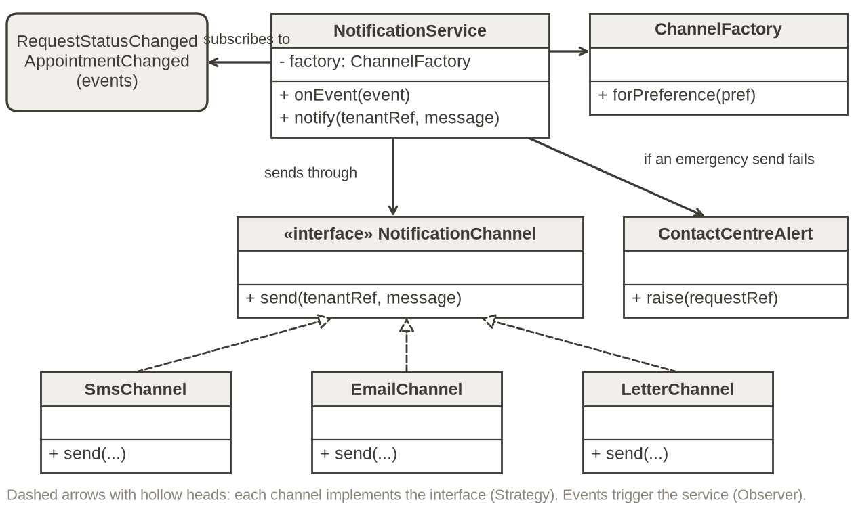
Figure 1. Notifications design (Session 5): Observer and Strategy, with an alert when an emergency send fails.
One traceability row
Requirement | Story | Screen | Class | Test
MNT-1: adding a channel needs no change to the repair request logic | As a tenant, I want updates by text, email or letter, as I choose, so that I know what is happening without phoning | Contact preferences | NotificationChannel and its three channels | Add a dummy channel class; every repair request test still passes unchanged

One security check: messages say what is happening and when, but never include the vulnerability note or any health details (DP-1, data minimisation).
Technical talk outline (for developers)
• Structure: status and appointment events trigger NotificationService (Observer), which sends through one NotificationChannel interface.
• Patterns: text, email and letter are interchangeable channels (Strategy), so a WhatsApp channel would be one new class (MNT-1).
• Risk: a failed emergency send raises an alert in the contact centre queue; it never fails silently (SEC-6).
• Trade-off: more classes to learn, and events are harder to trace, so every message logs the request reference.
Non-technical talk outline (for the Tenant Panel)
• Who it helps: tenants like Joan and Amir, who want to know what is happening without phoning.
• What changes: you choose text, email or letter, and you hear when a repair is booked or moved.
• Safety: if an urgent text does not arrive, an adviser is told at once and contacts you another way.
• What we need from you: up-to-date contact details and your choice of channel.

4. Two talks, two minutes each
You tell the board two short talks about the same design. The design does not change; what you say about it does.
Story | Cover | Avoid
Technical (developer, data protection officer) | Structure: the main parts and how they talk. Patterns: which ones, and the problem each solves. Risks: what could go wrong and what the design does about it. Trade-offs: what you gave up, and why. | Reading the diagram box by box; hiding the risks; naming patterns without saying why
Non-technical (tenant panel member, contractor supervisor) | Who it helps. What changes for them. What it needs from them, and what they no longer have to do. | Class names, acronyms and jargon; how it works inside; promises the design cannot keep

• Start with the problem, in one sentence.
• Share one diagram at a time, zoomed so the text is readable on a shared screen.
• Two minutes is about four points of one or two sentences each. Time yourself once.
• End with the part you most want challenged (your Prepare answer).

5. Role cards
Each turn, the board shares out these cards, always including at least one external role. Stay in role for the question round, ask one question at a time, and if the project is not Kestrel Moor, play the nearest equivalent person.
Role card: Tenant panel member (external)
Who you are | You represent the people who use the service. You are not an employee and you are not technical. At Kestrel Moor this is someone like Maureen Hughes, Chair of the Tenant Panel. For another project, play its users or customers.
You care about | Clarity and access: plain words, readable screens, not repeating yourself, and what happens when something goes wrong.
Ask | 1. What will I see first, and what do I do next?  2. How would someone with poor eyesight, or who reads English slowly, manage this?  3. If I make a mistake, or the service fails, what happens to me?
Feedback on | Clarity, accessibility, communication

Role card: Contractor supervisor (external)
Who you are | You run a team from an outside firm that will use part of the system, like Lee Carter at the gas and heating contractor. For another project, play a supplier or partner whose staff use it.
You care about | What your people need to do the job, what they do not need to see, and being told when something changes.
Ask | 1. What exactly will my people see, and is any of it more than they need?  2. How will we find out when something changes?  3. What happens to their access when one of my people leaves?
Feedback on | Completeness, security, communication

Role card: Developer
Who you are | You will build and maintain this design, in a small team like Priya Nair's four developers.
You care about | Structure, how easy it is to change, and how it will be tested.
Ask | 1. Where does this rule live, and how many places would change if it changed?  2. How would I test this requirement? Show me the row.  3. What happens when an external service is slow or down?
Feedback on | Consistency, traceability, completeness

Role card: Data protection officer
Who you are | You advise on UK GDPR and the organisation's data protection policy, like Tom Reid at Kestrel Moor.
You care about | Collecting and sharing only the personal data that is needed, keeping it safe, and failures that do not leak it.
Ask | 1. What personal data does this collect, and why is each item needed?  2. Who can see it, and how long is it kept?  3. What does a user see when something fails, and does it reveal anything?
Feedback on | Security, clarity

6. Feedback the designer can act on
A useful feedback point has four parts: where (the screen, class or table row), what you saw, which criterion it falls under, and one suggested change. One sentence can hold all four. Examples on a leisure-centre booking design:
Weak | Why it does not help | Specific
'Looks really good!' | Praise with no detail: nothing to keep or change | Consistency: the class diagram says Session but the booking screen says Class. Pick one name for both.
'The security needs work.' | No place, no criterion, no suggestion | Security, BookingService: it stores the member's date of birth to check age. Storing 'over 16: yes' would be enough.
'You've overcomplicated this.' | About the person, not the design | Clarity, sequence diagram: payment and email messages cross over. Split them into two diagrams that each read top to bottom.

Praise can be specific too: 'The error screen keeps what the member typed; keep that.' Write your two points on the feedback form and post them in the breakout room chat, starting with the presenter's name.

7. From feedback to a development goal
Feedback is only useful if something changes. In Activity 3 you make one change (or plan it, with a reason) and set one goal for your next module. A goal is specific (what and where), measurable (someone could check it) and dated.
Pattern: By [date], I will [action] on [what], checked by [who or how].

Example: another learner's log entry (a different design from yours)
Part | Entry
Feedback | 'Your sequence diagram shows no path for a failed payment.'
Change | Added the failed-payment path and a test for it.
Goal | Draw the main error path for every feature I design at work.
Measure | My lead checks two designs and finds the error path in both.
Date | By 26 February 2027, at my skills coach review.

Not goals: 'keep practising diagrams' (no end), 'become a better communicator' (cannot be checked).

8. Fallback brief: repair satisfaction survey
Copied from Case Brief Part 6 for convenience. Use it if you have no project of your own to design for, or if your project is too sensitive to show to people from other organisations. No clear scope after 5 minutes on your own project? Switch to this brief.
After a repair is marked complete, Kestrel Moor Homes wants to ask the tenant how it went. Today a sample of tenants is phoned by an agency, which costs money and reaches about 1 in 10. Dev Malhotra wants every tenant to be asked; Maureen Hughes wants it to be short and to make a difference; Tom Reid wants no more personal data collected than needed.
• The survey is sent by the tenant's preferred channel within 24 hours of completion: a text message with a link, an email with a link, or a letter with a phone number.
• Three questions: was the problem fixed (yes, no, partly); how satisfied are you (1 to 5); anything else you want to tell us (optional, up to 500 characters).
• A 'no' or a score of 1 or 2 creates a follow-up task for the repairs team within one working day.
• Tenants can opt out of surveys. Answers are reported to managers by area and trade, not by named tenant.
• The survey must meet the accessibility standard in Part 3.
What you need from the rest of the Case Brief. Accessibility (Part 3): visible labels, errors in text that say how to fix them, contrast 4.5:1 or more, tap targets at least 24 by 24 CSS pixels, plain English and one question per screen. Security and data (Part 5): SEC-2 users see only the data their role needs; SEC-5 errors never reveal personal data; DP-1 collect only the personal data needed.

9. Working without draw.io
• PowerPoint: one slide for each starter page (Wireframes, Analysis, Model, Traceability), with rectangles, connectors and a table.
• Paper: draw each page, photograph it with your phone and share the photo on screen during the board.
• The traceability table and security checks can go in a Word table if that is easier.

